400 companies joined the consortium

2 events :

_ emergence of Combo, another German-American standard (BMW, Volkswagen, GM) that will phase out CHAdeMO chargers in Europe

_ tepco problems with Fukushima no R&D

In fact, there are 4 major industrial consortia in the industry

History of CHAdeMO

Jul 2009 Market launch of i‐MiEV (Mitsubishi) and Plug‐in Stella EV (Subaru), the first CHAdeMOcompatible

EVs

Aug 2009 Foundation of CHAdeMO Association preparatory group

Nov 2009 NWIP (New work item proposal) submission for 61851‐23, followed by 61851‐24,

62196‐3

Mar 2010 Inauguration of CHAdeMO Association

Apr 2010 Publication of CHAdeMO standard specifications rev.0.9

May 2010 Start of charger certification procedure

Aug 2010 Launch of Specifications Work Group

Dec 2010 Market launch of Leaf (Nissan)

Jun 2011 Launch of Connector WG

Oct 2011 Launch of Specification 1.0 WG and V2H Extension Guideline WG

Jan 2012 Publication of CHAdeMO standard specifications rev0.9.1

May 2012 CD review for IEC 61851 finalized in IEC meeting (Tokyo), CDV to be reviewed

Sep 2012 Publication of JIS standard specification (TS D0007)

Apr 2013 CDV status for IEC61851 approved in IEC meeting (Toronto)

May 2013 Publication of CHAdeMO standard specifications rev.1.0.0

Nov 2013 Release of V2H Guideline 1.0

Jan 2014 FDIS approval of IEC 61851‐23, 61851‐24

(2013 activity report)

Strength of the company

Market share

Sales of EV in 2010-2014 : 368000, 80% fast chargeable

1100 US, 1700 Europe, 5000 Japan

More than 50 chaging station manufacturers

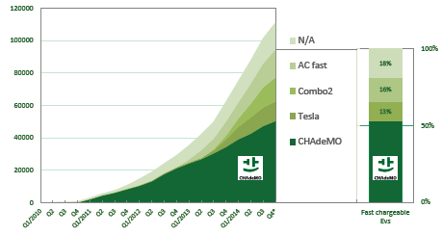

(final english brochure 2013)

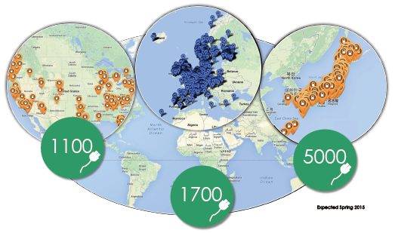

Deployment of CHAdeMO fast charger across the world (final English brochure 2013)

R&D of CHAdeMO

From 2005

Revenue/Profit

Patents/ technical specifications

Use the patented technology of TEPCO developed from 2005

_ safety of user

_ the connector inlet: one AC and one DC inlet to help customer make the difference

_ communication system (CAN) : physical communication network on the vehicle between the battery and the charger control unit

_ output power: tradeoff between the cost of the system (charger power, connection to the grid), and the benefit (time to charge the battery): level is 50kW

_future flexibility : the system allow to go up to 200A, which can almost double the power level

_ compatibility with smart grids: it is compatible for Vehicle-to-Home systems: allows to be connected to Home Energy Management System (connection with photovoltaic panels in the roof, optimization of charge and discharge)

Interlock of connectors

Security of the user (protection from electrical shock)

Protection of battery

Price

Service

Product

Monopoly

B2C/B2B companies government

Partnership

Private/public charging stations